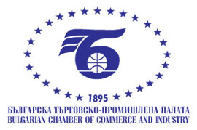

**Draft!**

**BUSINESS FORUM BULGARIA – ECUADOR**

13th march 2025

BCCI, 9 Iskar Str., fl.1, Hall A

**PROGRAMME**

|  |  |
| --- | --- |
| **09.30 – 10.00** | **REGISTRATION** |
| **10.00 – 10.15** | **OFFICIAL OPENING**  ***Mr. Tsvetan Simeonov***  President of the Bulgarian Chamber of Commerce and Industry  Lider of the Ecuador delegation |
| **10.15 – 10.30**  **10.30– 10.45**  **10.45 – 13.30** | **PRESENTATION** of the economy and business opportunities in Bulgaria  **PRESENTATION** of the economy and business opportunities in Ecuador  **B2B meetings** |
|  |  |

*Working language: English*